V12 Spin On Filter Conversion
Installation Notes

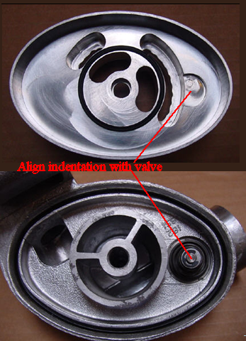
Warning: The adapter must be installed as shown, to allow clearance for the relief valve and alignment of flow passages. If you install upside down, engine damage can result.

Step 1. Remove old filter and canister. Retain the canister should you later wish to revert to stock configuration.

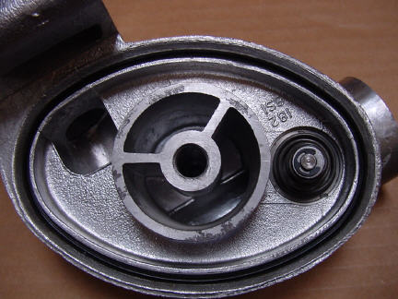
Step 2. Thoroughly clean the filter head, making sure to remove the original o-ring. Install the supplied large o-ring. It is very important to make sure that the o-ring is installed without twists. When installed properly, it will be perfectly square in the groove, otherwise the adapter will leak.
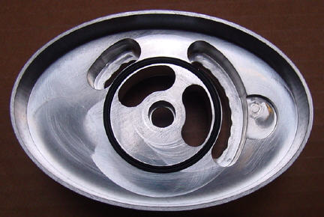
Step 3. Install small o-ring in groove on adapter. It must fit squarely in the groove with no kinks.

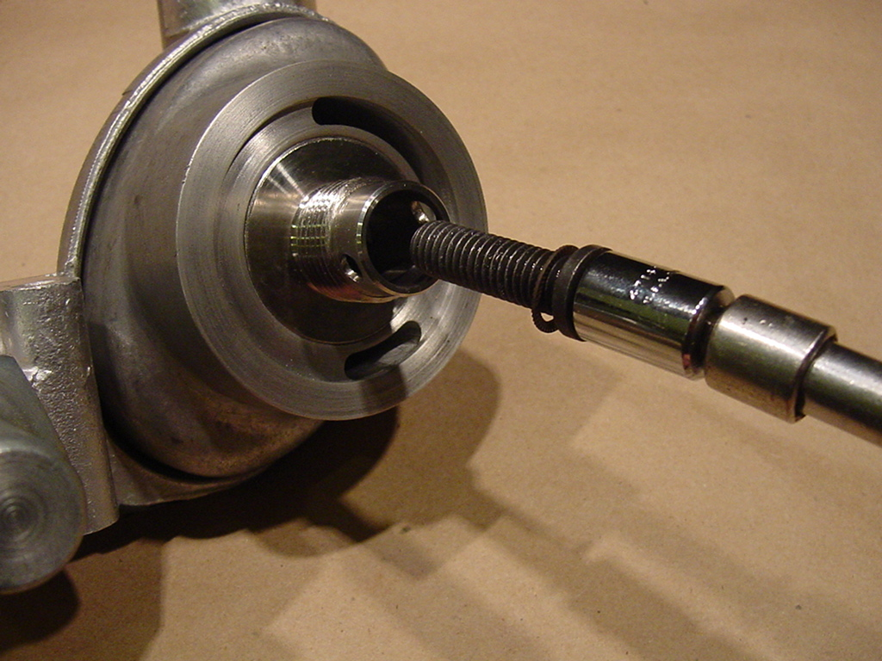
Step 4. Bolt adapter to filter head, using supplied bolt and washer. The concave face of the washer should face the adapter. Use the enclosed 12 point socket with a suitable extension to install. DO NOT attempt to remove the steel spigot

Step 5. Install spin on oil filter. You may use any filter from the following table:

Application | Part Numbers | Comments
1999-present Jaguar V8 all,  2000-present Lincoln LS 3.9L  2002-present Ford Thunderbird | Purolator L15317  Fram PH5618  Hastings LF510  Motorcraft FL2008  Jaguar EAZ1354 | - 4.69”x 2.99”  - Relief: 14-17 PSI

