SS3AWP Installation Notes

This switch will completely replace the 3AW relay that’s commonly used to operate the ignition warning light in your dashboard. Installation involves three easy steps:

- Disconnect the three wires going to your 3AW relay. You can leave the old relay in place, just for show.

- The SS3AW has three wires, connect these to your harness as follows:

Wiring Harness | SS3AWP | Original 3AW  (for reference)
White Brown | Black | WL
Green/Yellow | Yellow | AL
Red | Orange | E
Diagram | 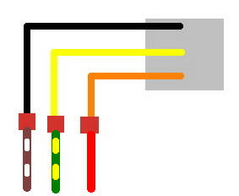 | 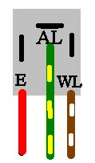

Make sure the connectors are fully seated, and that the insulators cover the connection. If necessary, use some electrical tape to ensure that the fittings are well insulated.

Note: if your harness is discolored, the wires can be identified with a meter, as follows. With the ignition off, measure the resistance between each wire and ground. The “red” wire will read close to zero ohms. Next, turn the ignition switch “on”, but don’t start the engine. Set your meter to read voltage. There will be close to 12V between the “Brown/White” wire and ground, and no voltage between the “Green/Yellow” wire and ground.

- Using a tie wrap, tie the SS3AWP to the wiring harness, and tuck the wiring out of sight.

